**Augment Reality Objects Prototype**

The aim of this prototype is to answer the technical question of is “marked tracking” a viable method of displaying and moving objects in our augmented reality 3d space with particular emphasis on range and accuracy.

**Initial prototype**

The first attempt at displaying and moving augmented reality objects was created on Unity using the Vuforia [reference] augmented reality library. It works by setting up a database of markers/trackers which are objects with enough unique elements to be picked up by a camera and be distinguishable from their surroundings. We then attach computer generated 3d objects to these “targets”, and when the software is ran the user can visualise these augmented reality objects superimposed on top of their real tracker cards.

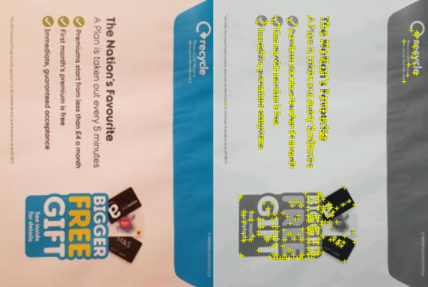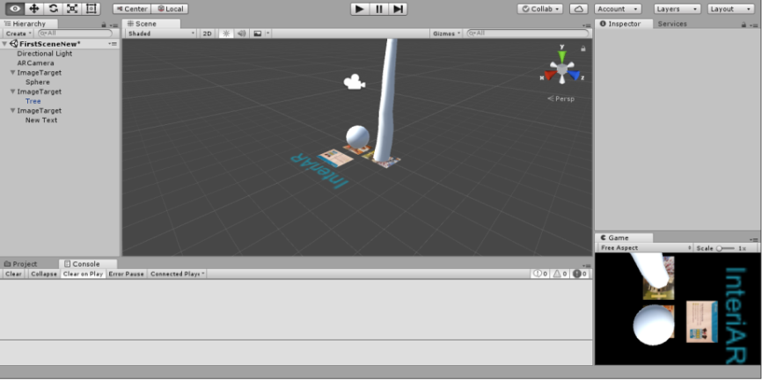

Vuforia AR objects prototype v1 in Unity Marker/tracker displayed with “features”

ADD PICTURE OF WORKING PROTOYPE (AND ALSO PIC OF TOO FAR OUT OF RANGE TO SHOW DOWNSIDES).

Talk about what I learned about methods; say we want to go for marker less probably?